**DAILY ONLINE ACTIVITIES SUMMARY**

|  |  |  |  |  |  |  |  |
| --- | --- | --- | --- | --- | --- | --- | --- |
| **Date:** | | **30/5/2020** | | | | | |
| **Name of the Faculty** | | **REENA LOBO** | | | | | |
| **No. of Students Allotted for monitoring** | | | | | **19** | | |
| **Progress** | | | | | **GOOD** | | |
| **Whether collected report from all the allotted students** | | | | | **18** | | |
| **Online Test Summary** | | | | | | | |
| **Subject** |  | | | | | | |
| **Semester** |  | | | **Duration** | |  | |
| **No. of students Taken** | | |  | **Passing %** | |  | |
| **Certification Course Summary** | | | | | | | |
| **Course** | | . Attended webinar on The chatbot, **Certificate provider: pantech solutions** Duration of the course:1hr | | | | | |
| **Certificate Provider** | |  | | | **Duration** | |  |
| **Coding Challenges** | | | | | | | |
|  | | | | | | | |
| **Status:** | | | | | | | |
| **Uploaded the report in Github** | | | | | **yes** | | |
| **If yes Repository name** | | | | | <https://github.com/reenalobo/ONLINE-ACTIVITY-REPORT/upload/master> | | |
| **Uploaded the report in slack** | | | | | **yes** | | |

Certification Course Details: (Attach the snapshot and briefly write the report for the same)

**Attended webinar on CHATBOT**

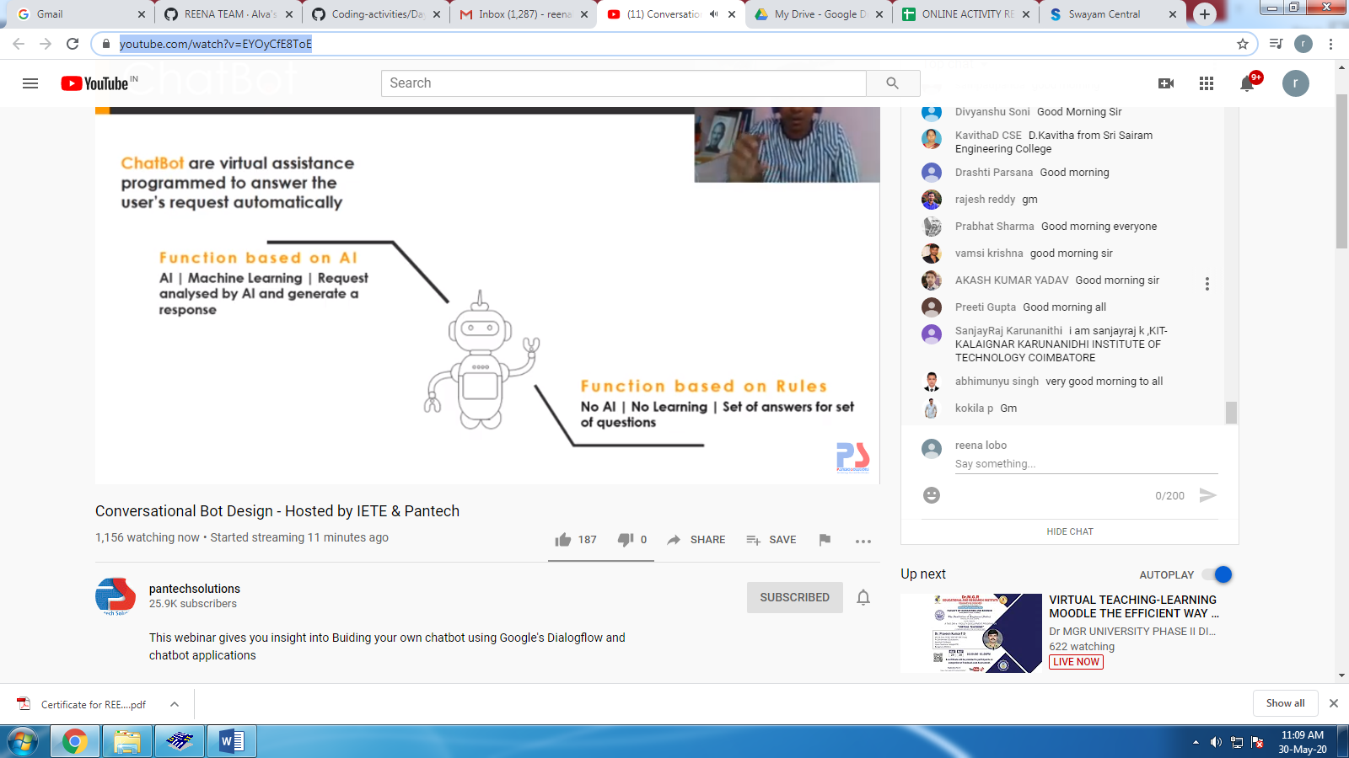

STUDENTS REPORT:

ROHAN MAHAVEER:

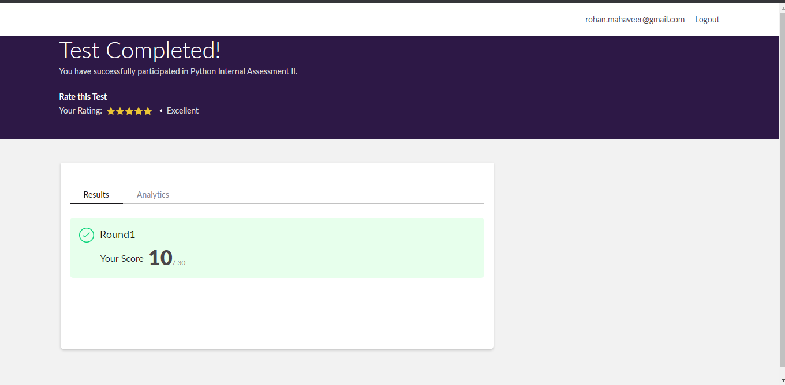

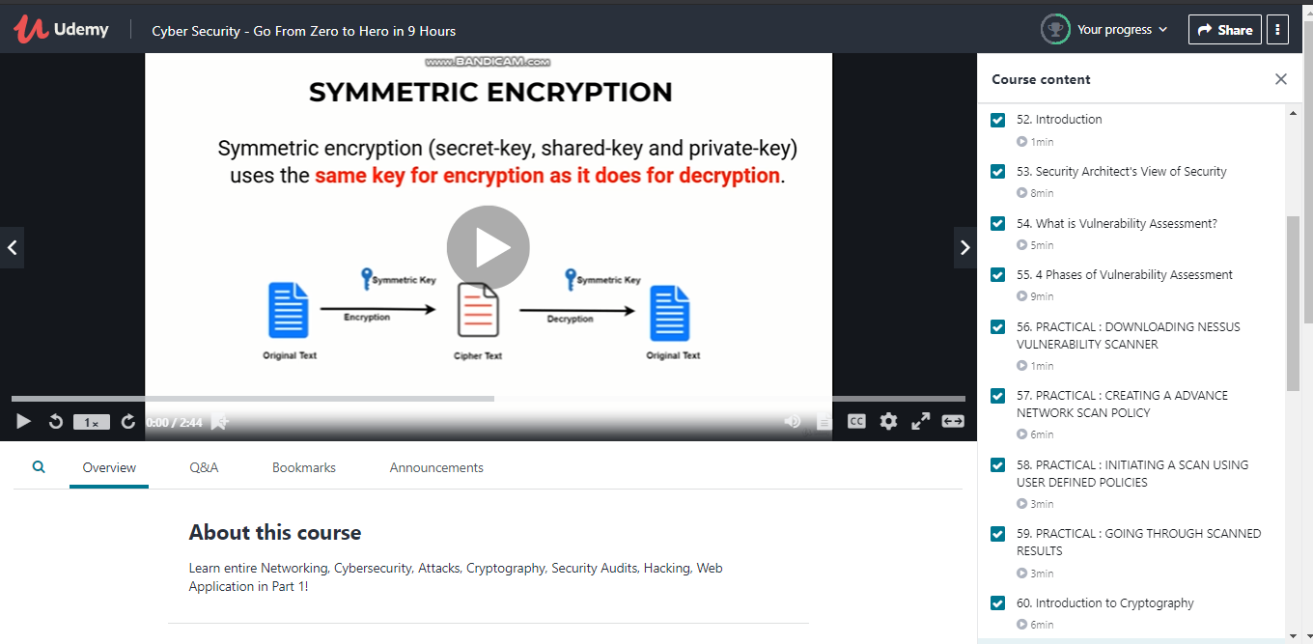

ATISH:

Second I A of PAP

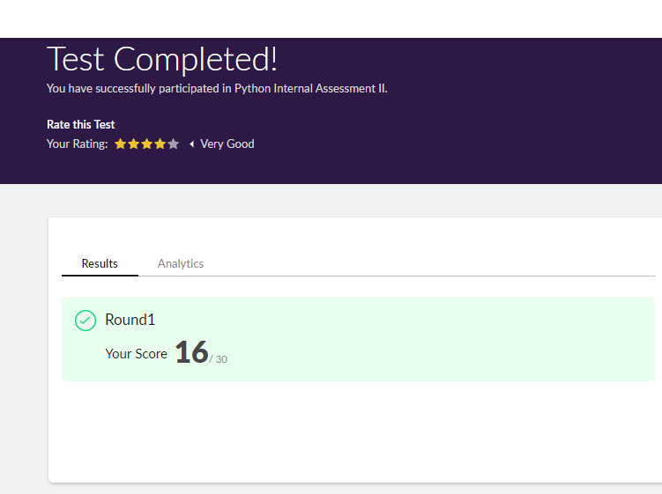

Certification Course Details:

Report

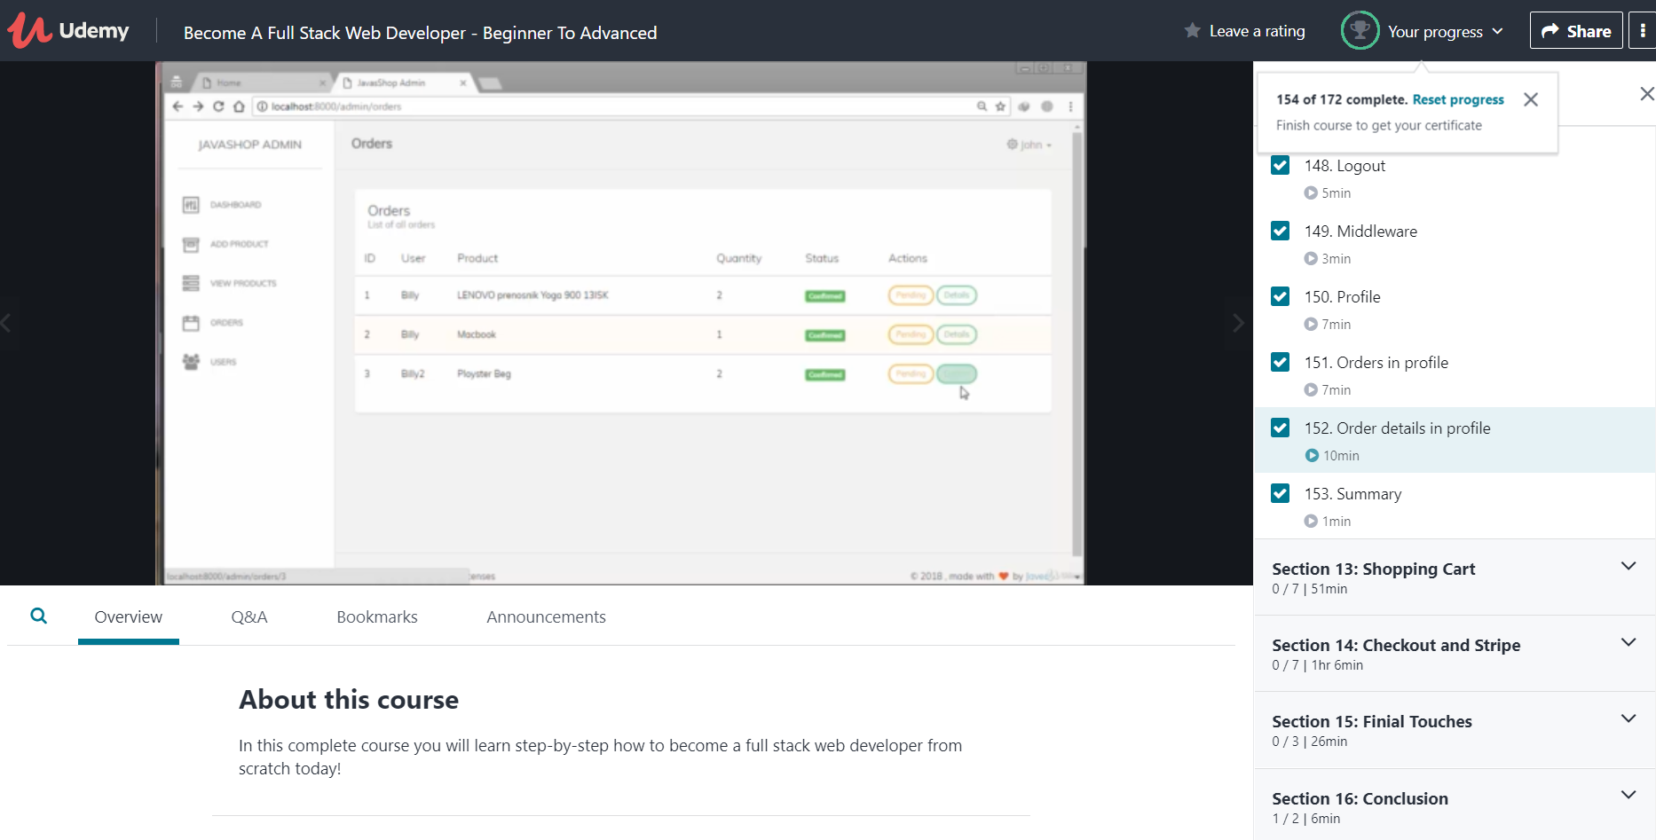

**Shah Dhruvil Amit:**

Second I A of PAP

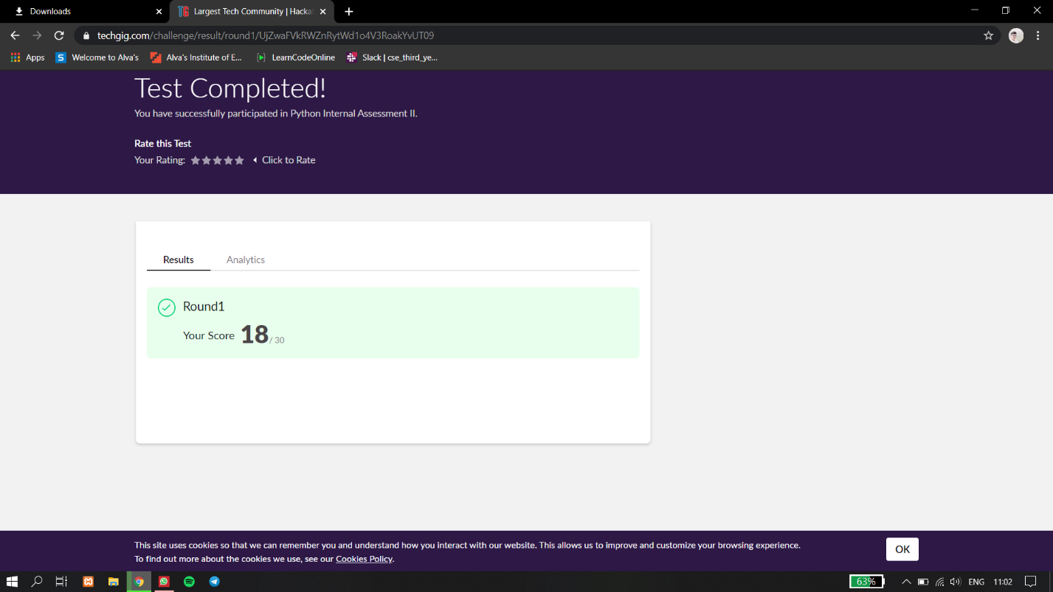

Certification Course Details:

Report

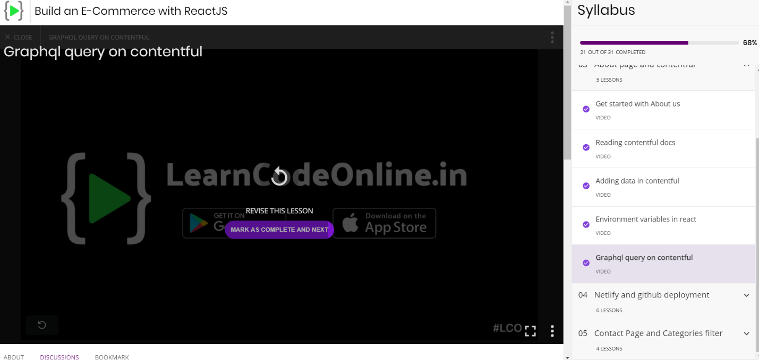

In today’s session for online certification I have learned about using environment variables in react as well as applying graphql query on contentful where the database is stored.

Coding Challenges Details:

The below GitHub link for details

<https://github.com/DhruvilShah99/Daily-Updates>

P-1

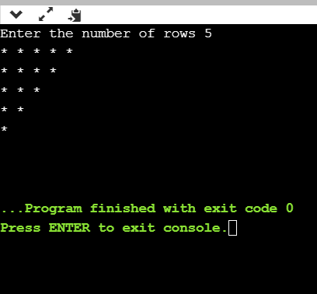

**Raksha S:**

Online Test Details:

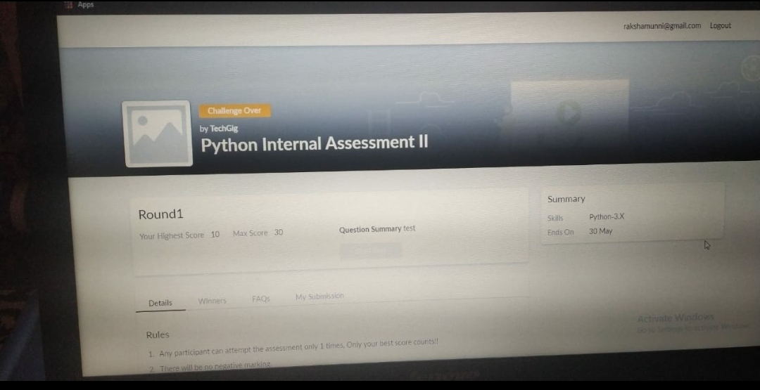

Scored 10 out of 30 in Python 2nd I.A test

Certification Course Details:

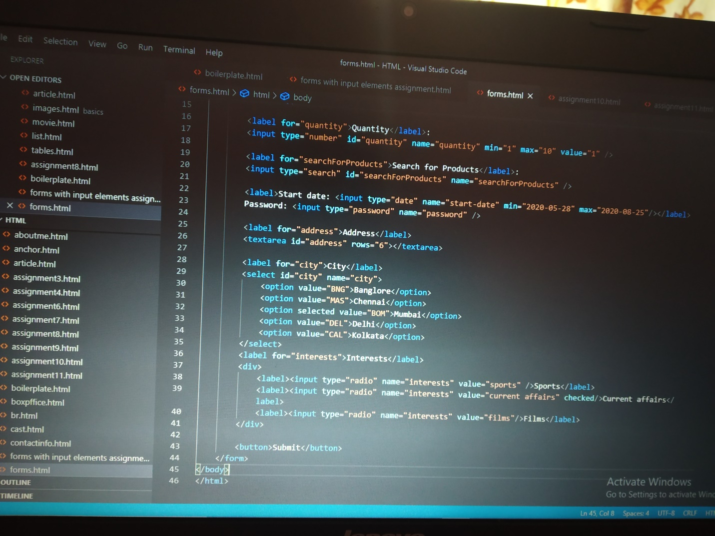

**Preethi:**

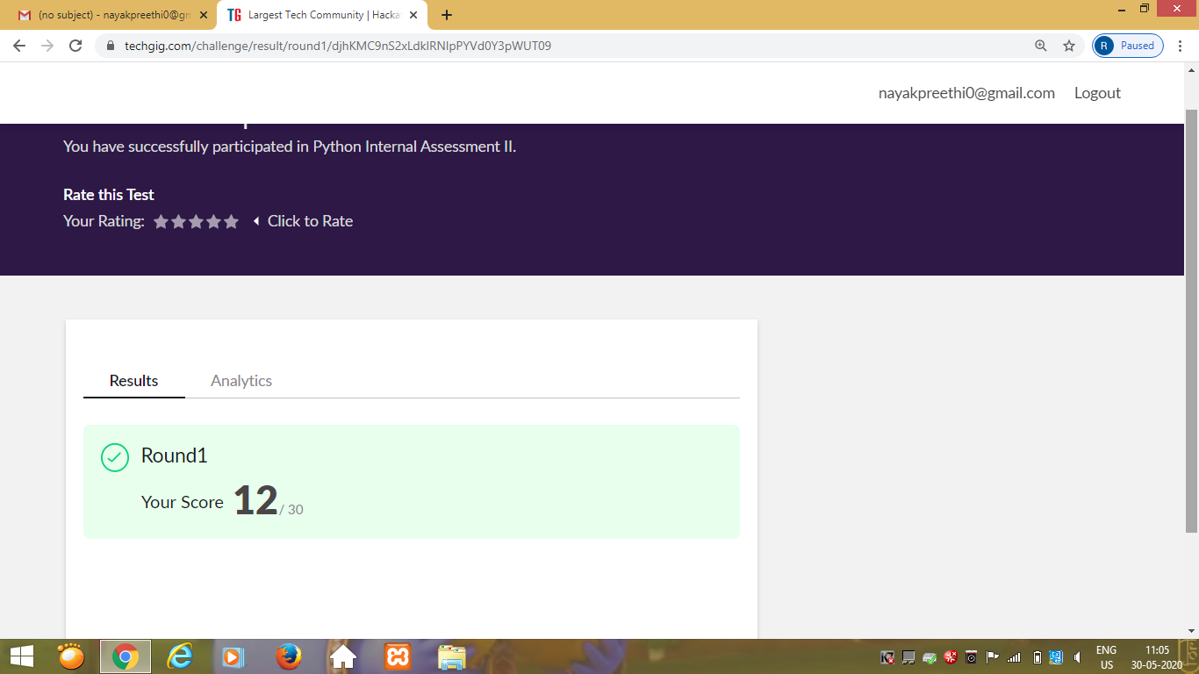

Certification Course Details: (Attach the snapshot and briefly write the report for the same)

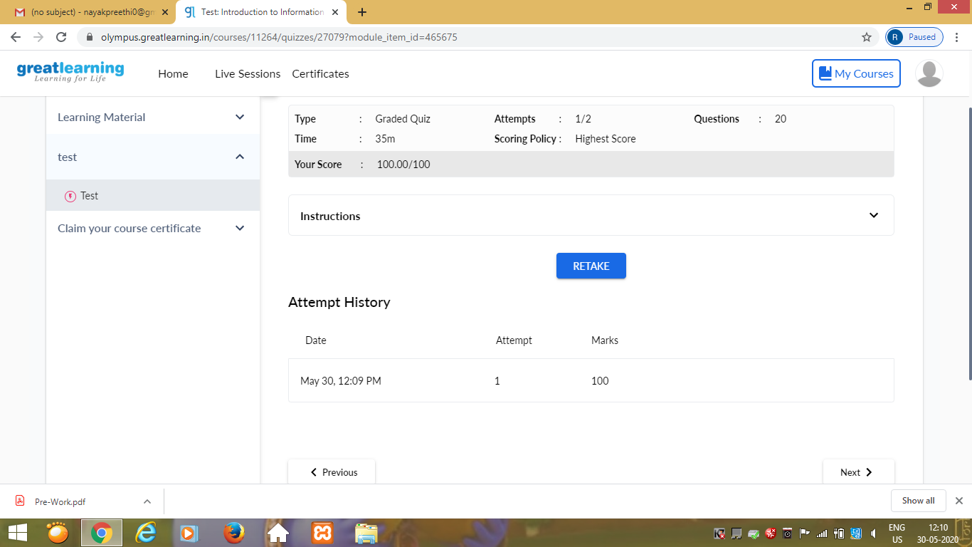

Rani:

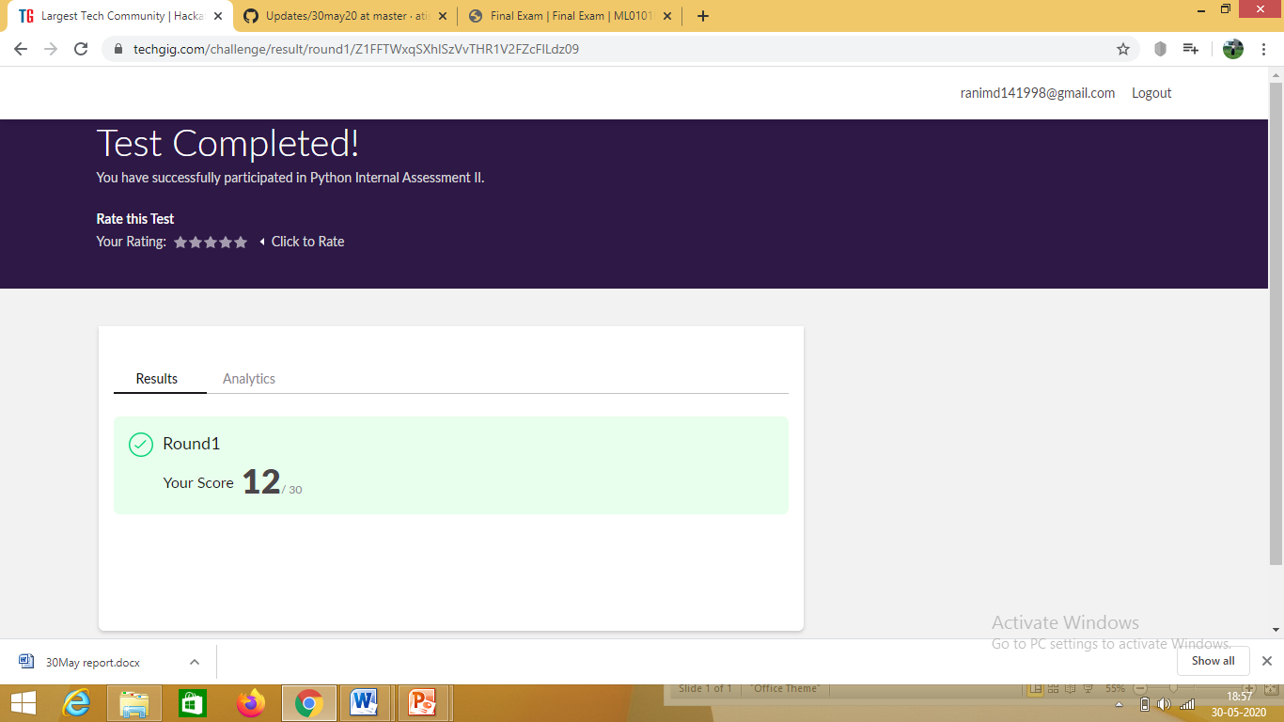

Certification Course Details: (Attach the snapshot and briefly write the report for the same)

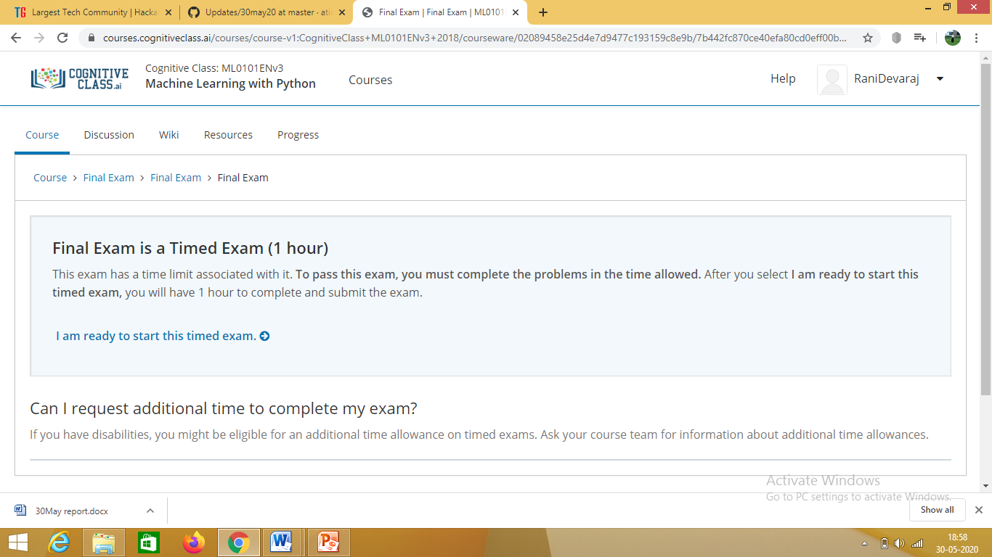

**Attended final exam of Python**

**Pranav L M:**

Online Test Details:

SECOND I A of PAP

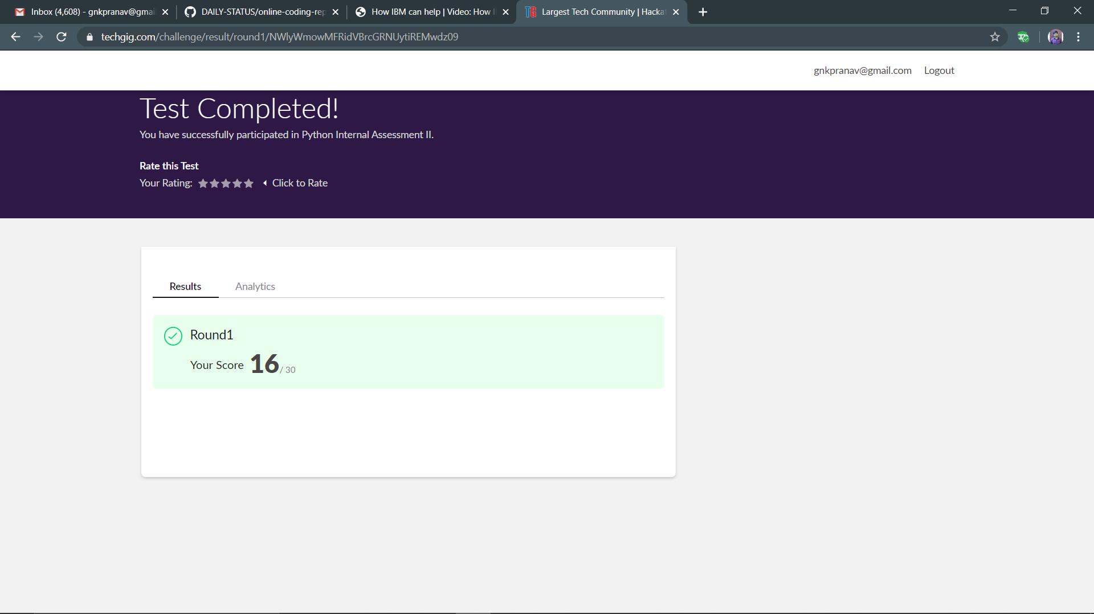

Certification Course Details:

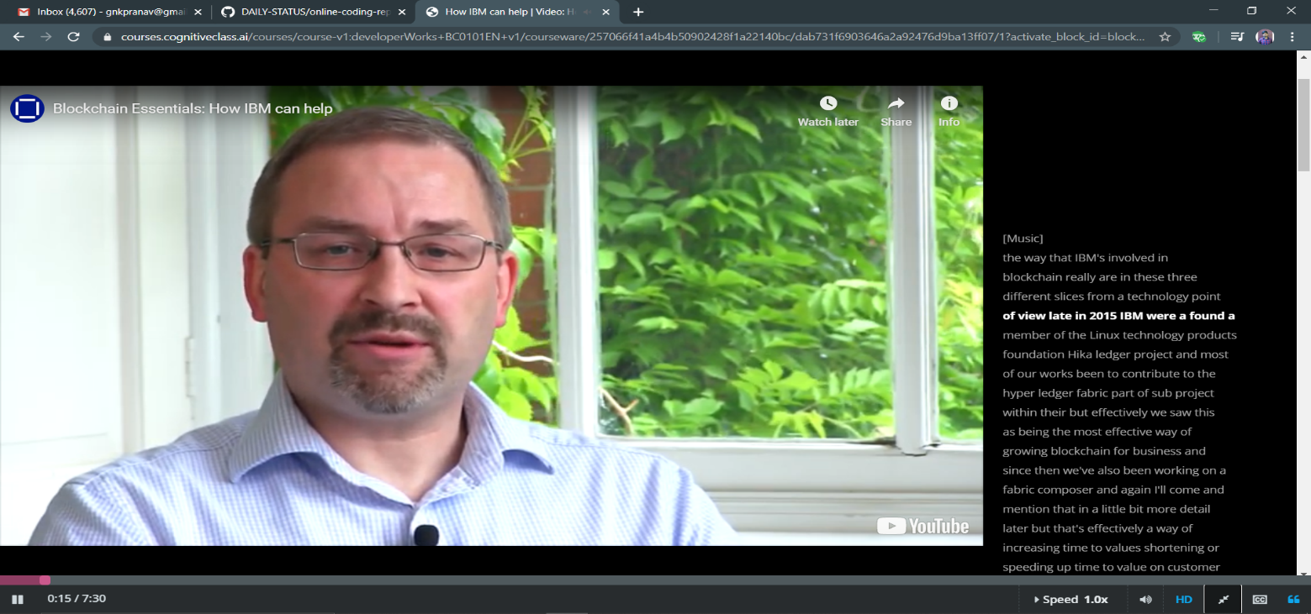

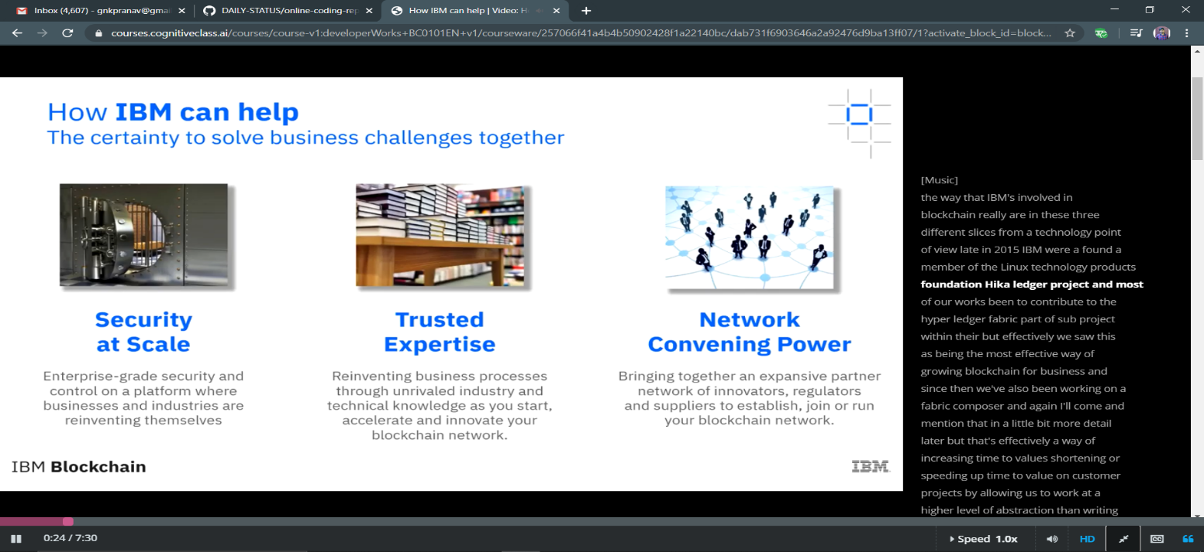

Coding Challenges Details:

P-1

RAVALI:

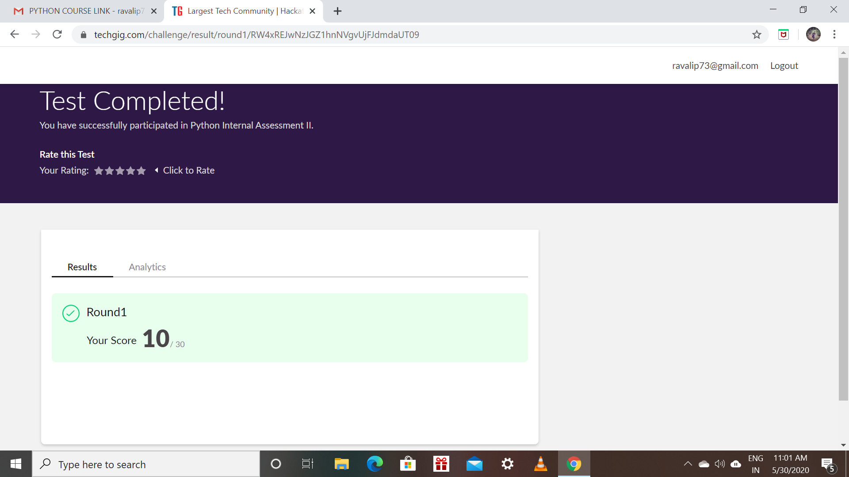

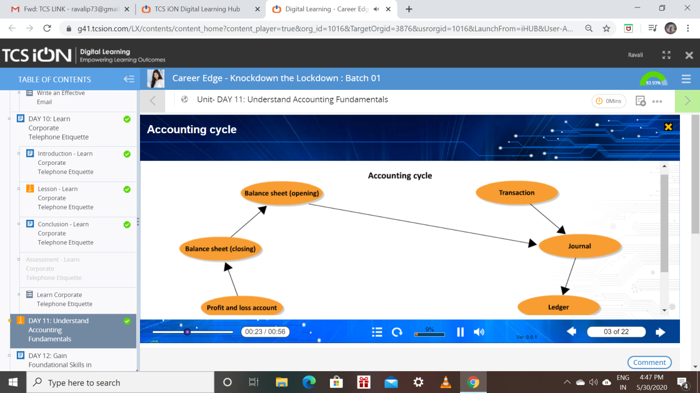

Priyanka:

**Online Test Details:**

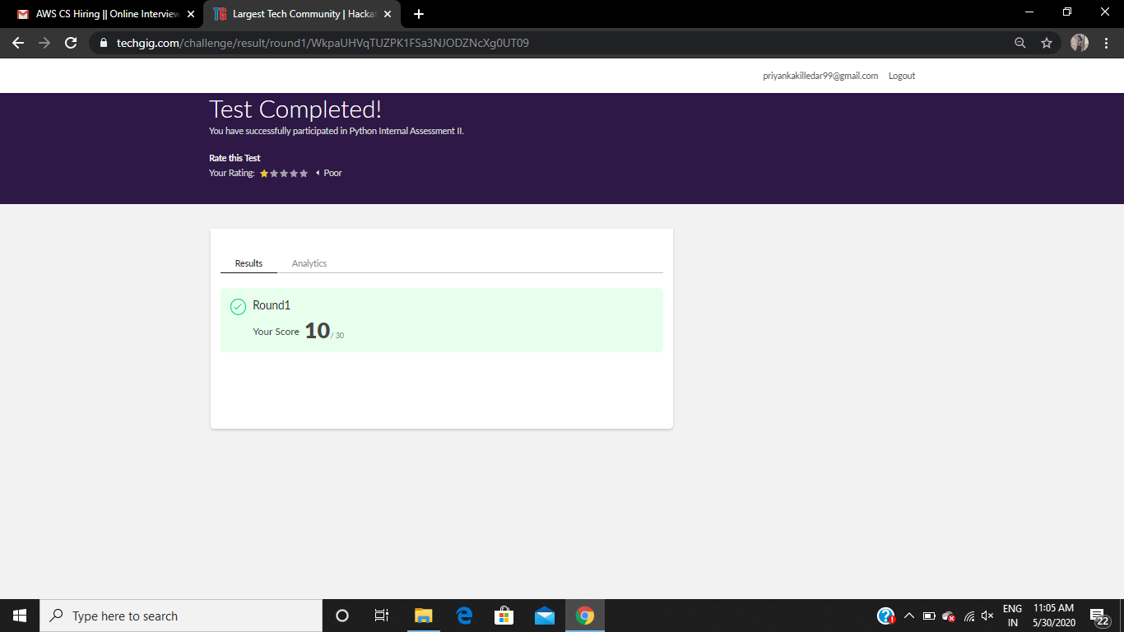

**Certification Course Details:**

**Today Progress:**

Priya:

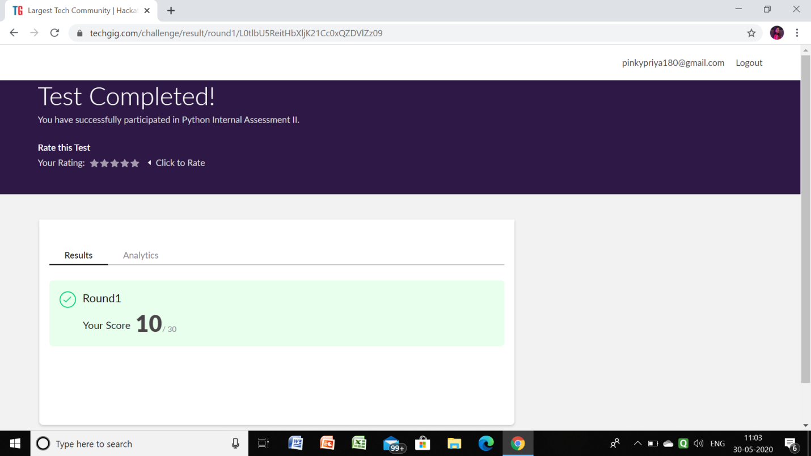

**Certification Course Details:**

Github link for information: <https://github.com/priya3028/Daily-status>

Rousha:

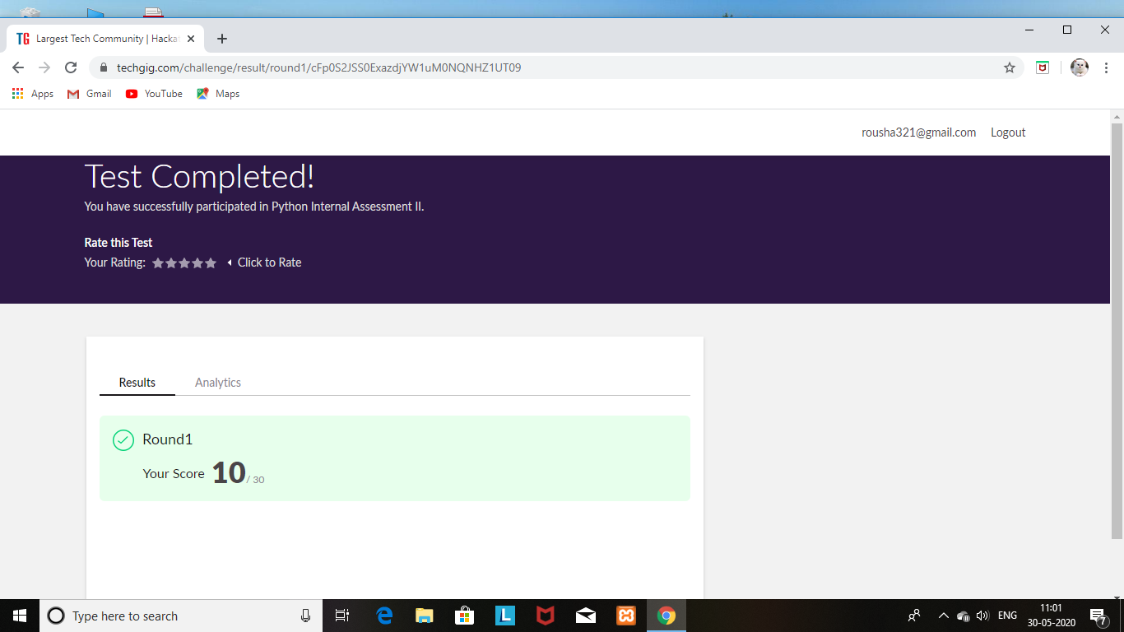

Certification Course Details: (Attach the snapshot and briefly write the report for the same)

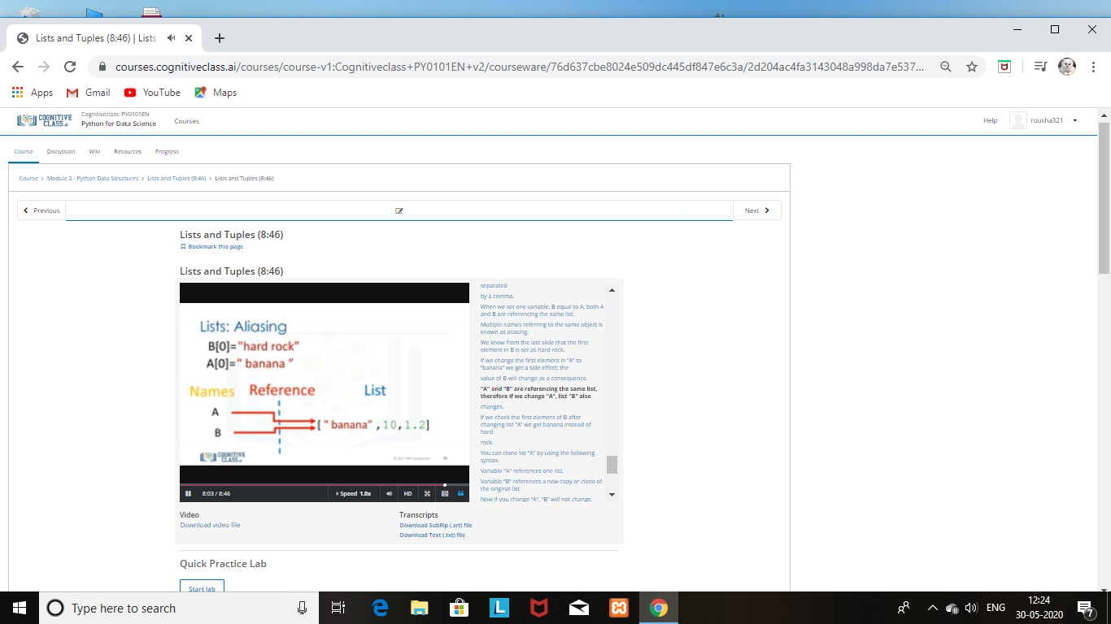

SHAIFA:

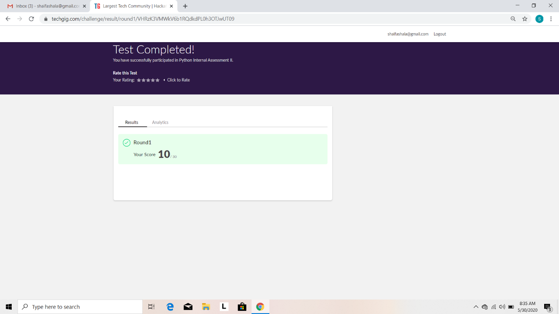

Certification Course Details: (Attach the snapshot and briefly write the report for the same)

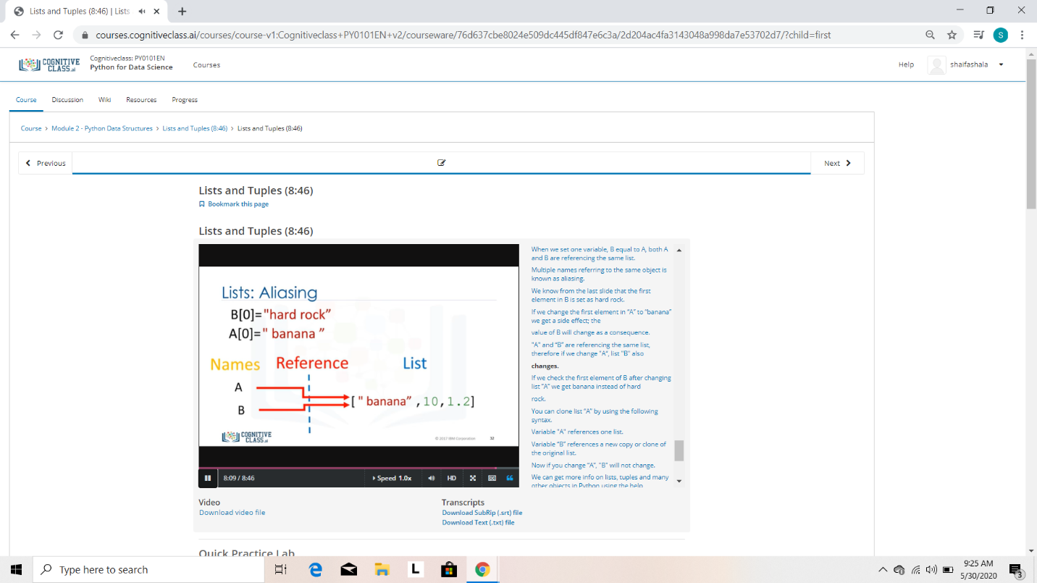

Rani:



Certification Course Details: (Attach the snapshot and briefly write the report for the same)



Sana:

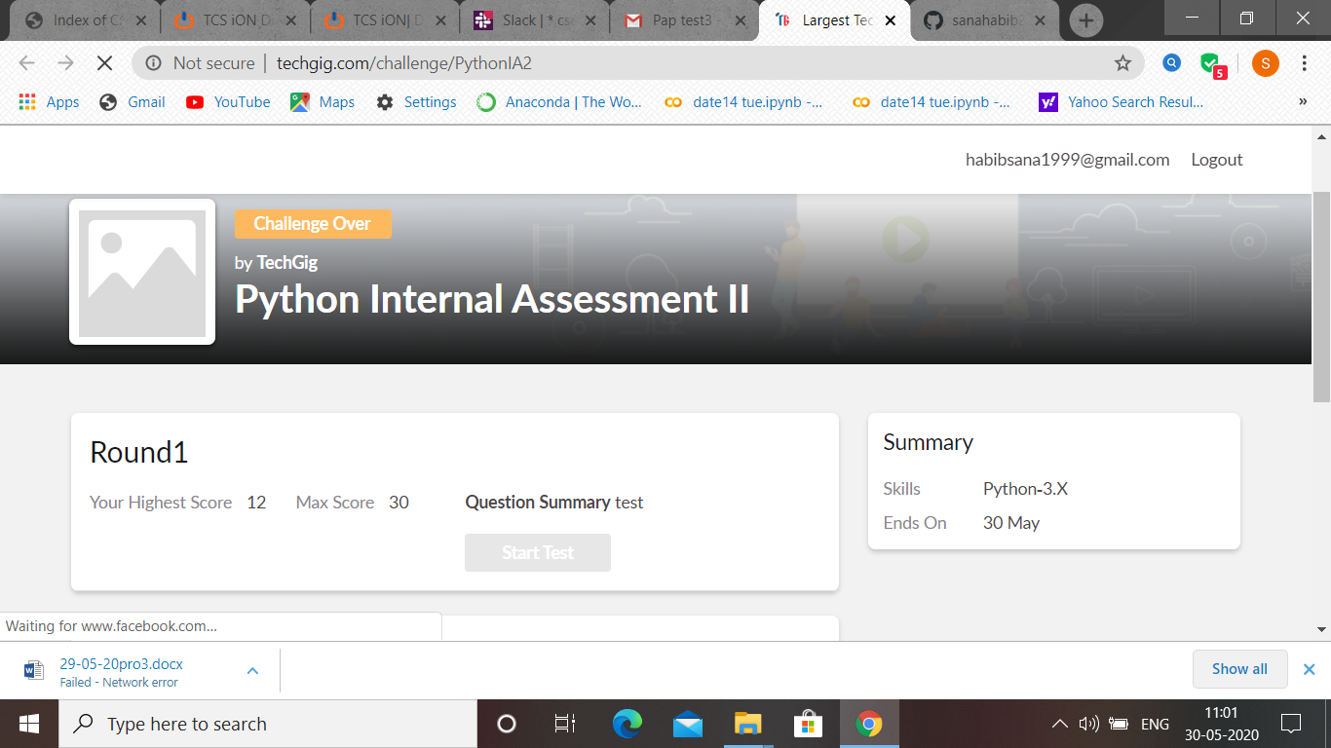

PAP test 2 was held today i.e 30 May 2020. Out of 30 marks I scored 12.

Certification Course Details: (Attach the snapshot and briefly write the report for the same

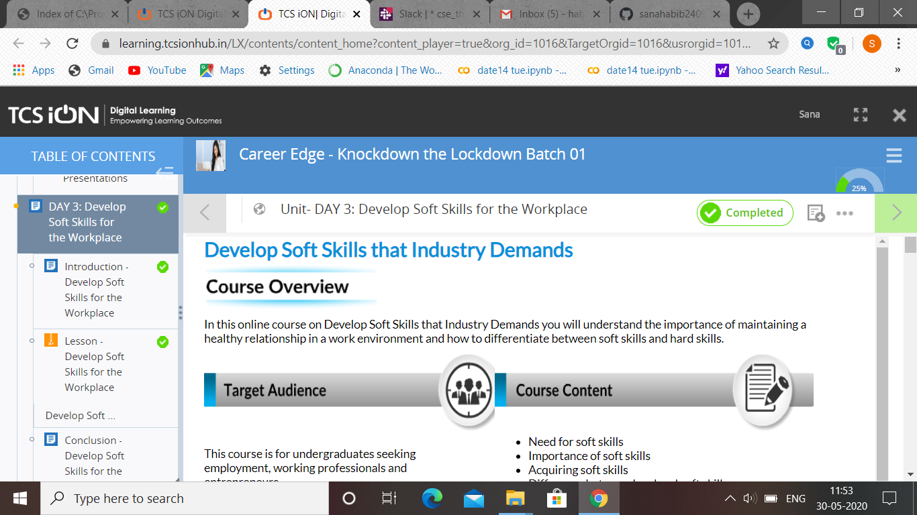

Rachana:

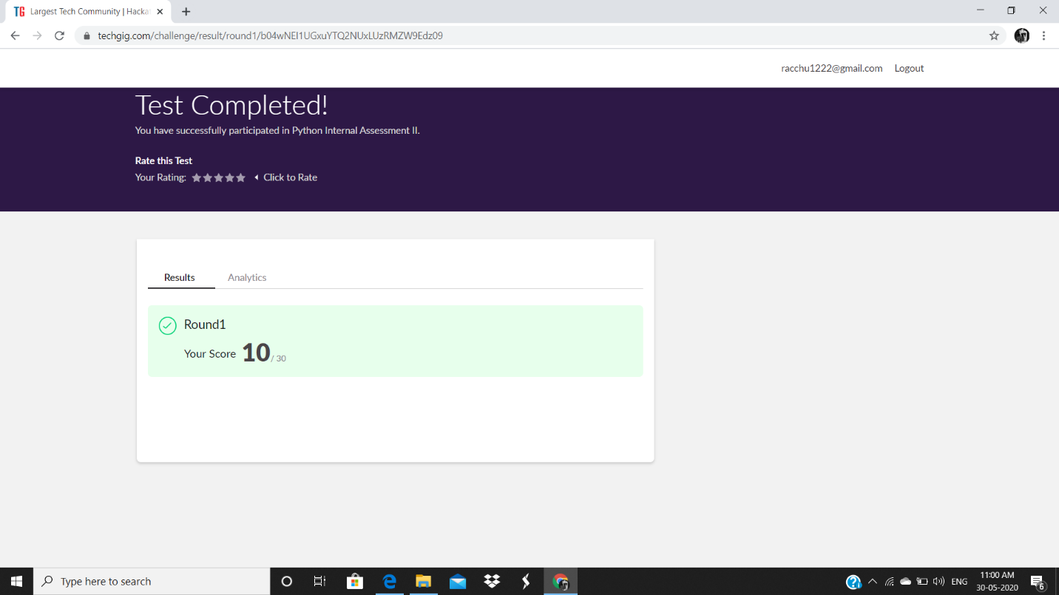

**Certification Course Details:**

**Today Progress:**

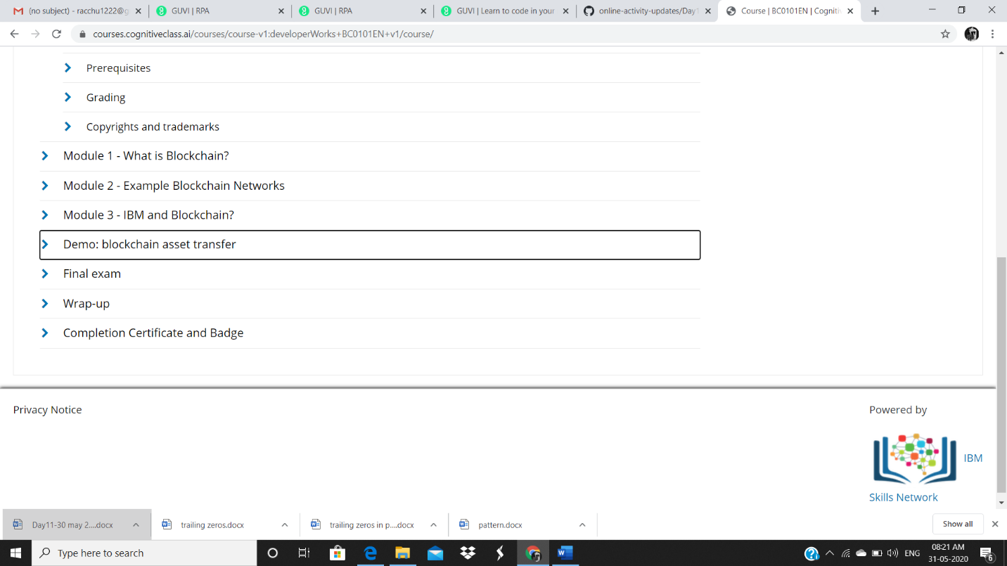

Raghavi:

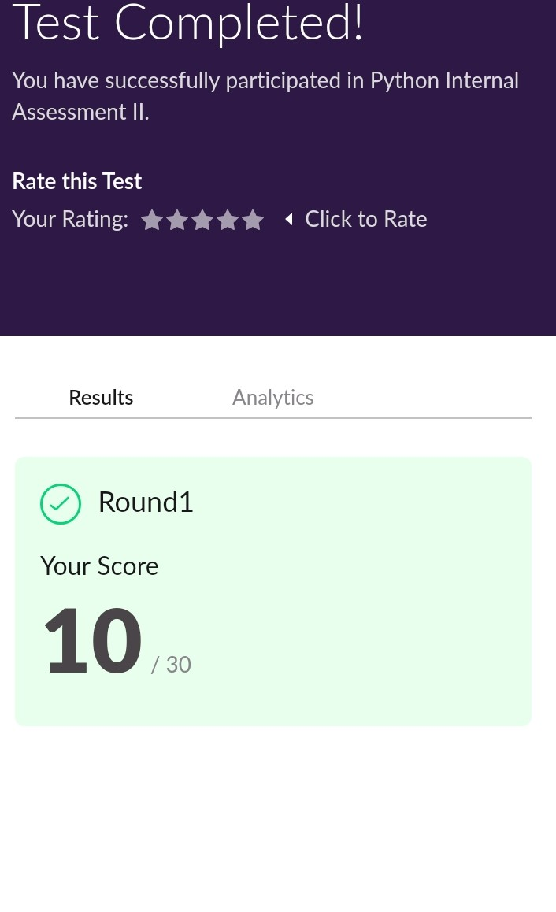

ROHAN VASISTA:

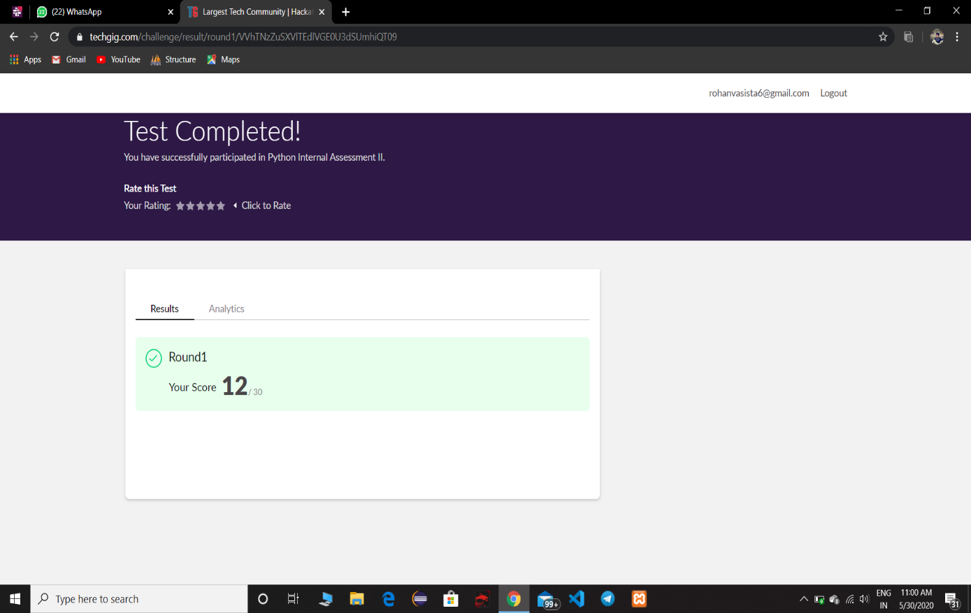

**Online Certification Details**

Completed modules

* SQL fundamentals
* Introduction
* SQL statements,syntax’s
* Selecting multiple columns
* DISTINCT and LIMIT
* QUIZ

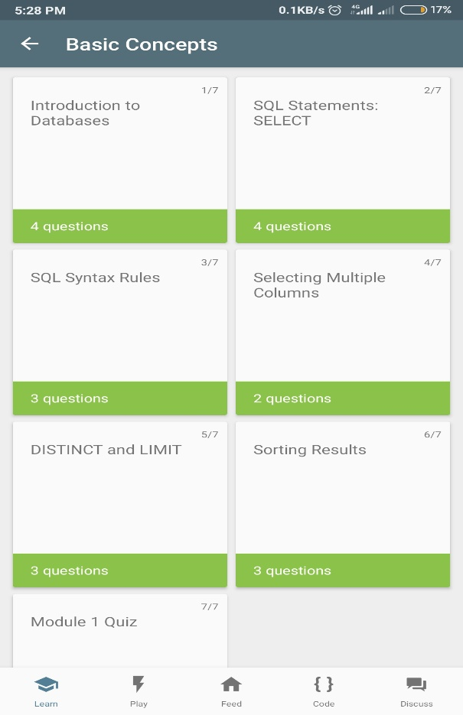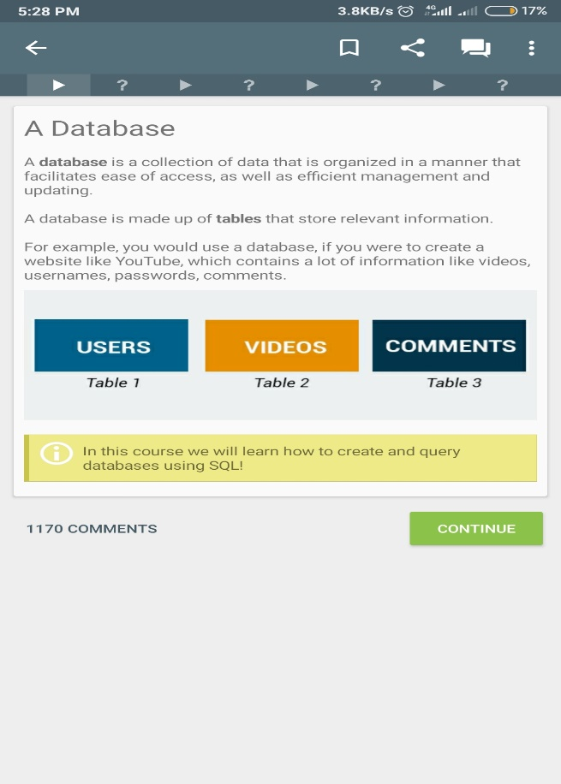

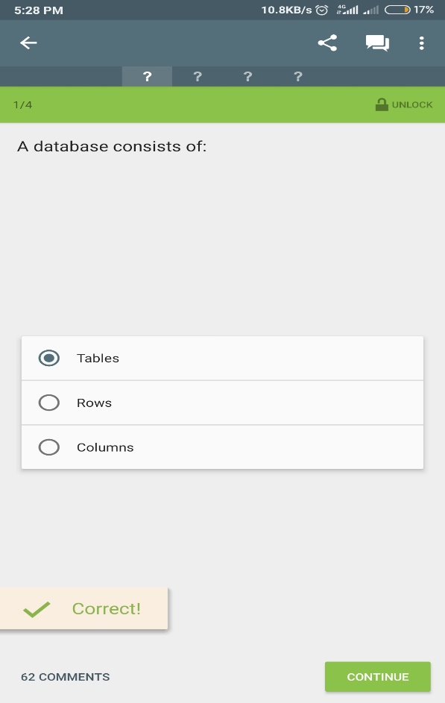 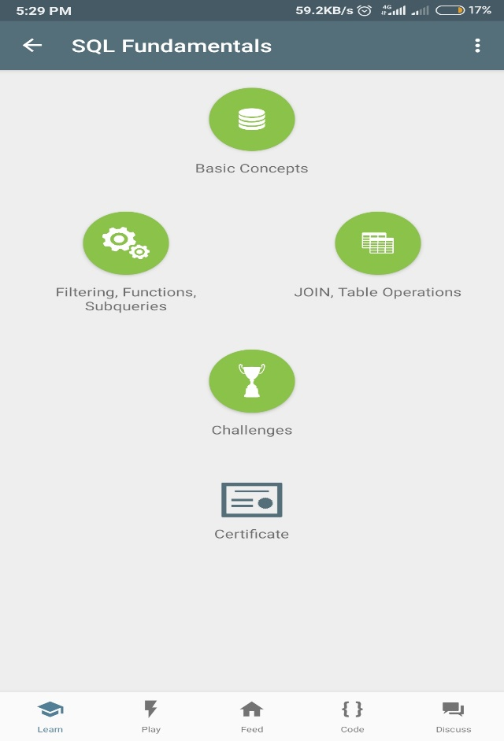

**CERTIFICATE OF COMPLETION**

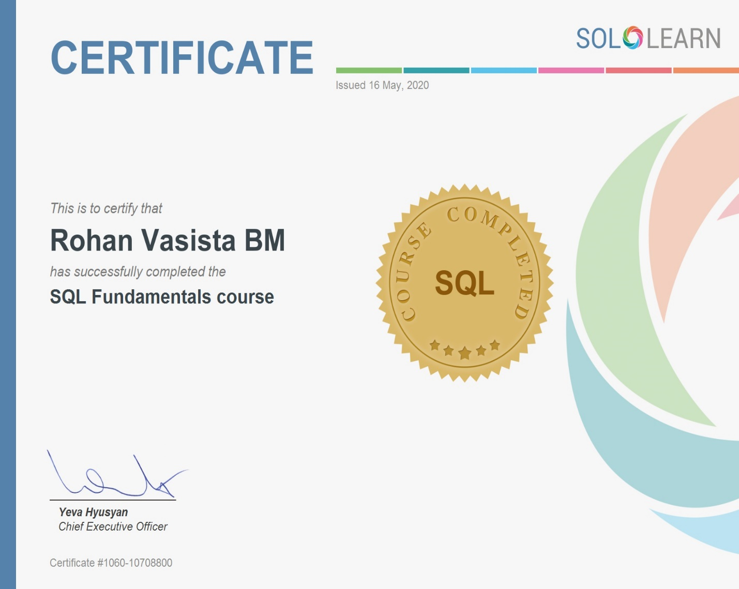

SACHIN:

